# Create a ViewMaster Calculated Column with HTML/JavaScript code

# http://viewmaster365.com/#/How

* [ViewMaster365](http://viewmaster365.com/viewmaster365)

# Create a ViewMaster: Calculated Column with HTML/JavaScript code

#### You do NOT need:

* CEWP or other Webparts
* SharePoint Designer
* Visual Studio
* CSR / JSlink

#### You do need:

* List Manage Rights on:
  + SharePoint 2010  
    or SharePoint 2013  
    or SharePoint Online

ViewMasters work because, since SharePoint 2010 a Calculated Column set to datatype=Number is evaluated as full HTML by the Browser.

ViewMasters only work in SharePoint List or Library **Views**

Read the [How](http://viewmaster365.com/How) section for a detailed explanation.

### 5 free and documented ViewMasters:

### [Color Row by Priority value and update Priority with one button](http://viewmaster365.com/Create/Priority)

[[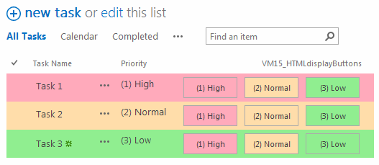](http://viewmaster365.com/Create/Priority)](http://viewmaster365.com/Create/Priority)

### [Sum a Calculated Column in a Standard View](http://viewmaster365.com/Create/Sum)

[[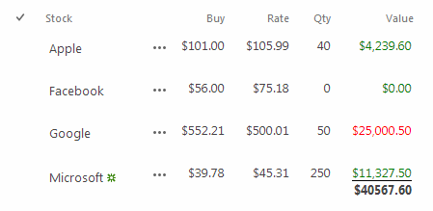](http://viewmaster365.com/Create/Sum)](http://viewmaster365.com/Create/Sum)

### [Change Created Date with a HTML5 Datepicker (Chrome Browser)](http://viewmaster365.com/Create/Changedate)

[[](http://viewmaster365.com/Create/Changedate)](http://viewmaster365.com/Create/Changedate)

### [auto Filter View List Items with the Search Input box](http://viewmaster365.com/Create/SearchFilter)

[[](http://viewmaster365.com/Create/SearchFilter)](http://viewmaster365.com/Create/SearchFilter)

### [delete ListItems in a View with One Click](http://viewmaster365.com/Create/ActionDelete)

[[](http://viewmaster365.com/Create/ActionDelete)](http://viewmaster365.com/Create/ActionDelete)

## [Create your own ViewMaster](http://viewmaster365.com/Create/) or check out:

# ViewMaster Tasks

productivity enhancements using Standard SharePoint Columns: Priority, Status, PercentComplete (Progress)

[**see the video on YouTube**](https://www.youtube.com/watch?v=LOHsVH_xsNA)

Download from the Office App Store for US$ 9.99

[or try the Free version](https://store.office.com/viewmasters-WA104379124.aspx?assetid=WA104379124)

### Enhance Libraries & Lists with:

1. Colored Priority (+ One Click Update)
2. Task Status/Choice selector (+ One Click Update)
3. Progress Bar (+ One Click Update)
4. Day counter

* Automatic color higlighting rows or cells based on current Priority field OR (Due)Date counter   
  Colors can be changed **after installation** in the Calculated Column: ViewMasterConfiguration

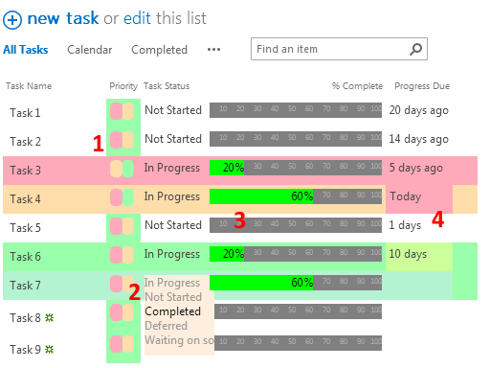

Create your own

ViewMaster365 develops *SharePoint* List & Library View productivity enhancements for Office365, SharePoint 2016, 2013